

DIGITAL CARE

Submitted to the
Department of Master of Computer Applications
in partial fulfilment of the requirements
for the Project (MCA51)

by

Asha Sheeba J
(1MS17MCA07)
Dilip Kumar
(1MS17MCA13)

Under the Guidance of
Chethan Venkatesh
Assistant Professor

Ramaiah Institute of Technology
(Autonomous Institute, Affiliated to VTU)
Bangalore – 54

2019

DEPARTMENT OF MASTER OF COMPUTER APPLICATIONS

CERTIFICATE

This is to certify that the project entitled Digital Care is carried out by

Student Name USN
1) Asha Sheeba J 1MS17MCA07
2)Dilip Kumar 1MS17MCA13

students of 5th semester, in partial fulfillment for the Project (MCA51), during the academic year 2019-2020.

Guide Head of the Department
Chethan Venkatesh

Name of Examiners Signature with Date

DECLARATION

I hereby declare that the project report entitled “Digital Care“ based on study undertaken by me, towards the partial fulfilment for the Project (MCA51) carried out during the 5th semester, has been compiled purely from the academic point of view and is, therefore, presented in a true and sincere academic spirit. Contents of this report are based on my original study and findings in relation there to are neither copied nor manipulated from other reports or similar documents, either in part or in full, and it has not been submitted earlier to any University/College/Academic institution for the award of any Degree/Diploma/Fellowship or similar titles or prizes and that the work has not been published in any specific or popular magazines.

Place: Bangalore Asha Sheeba J
Date: 1MS17MCA07

Dilip Kumar
1MS17MCA07

Abstract

Digital Care is an app that can track and monitor the child location. The aim of the project is to create a system to allow the parents to keep track of their child when their child is out of their view. However, with this system the parent can track and monitor their child location in just a simple app when the parent is in office or from anywhere they are present at.

The application works with the help of android mobile. The android application based on GPS service is used for tracking exact location of child. There are two android mobile phones for the safety of the both module. The system tracking the child from source to destination i.e. from home to school or anywhere.

Table of contents
- Introduction
  - Problem Definition
- Functional Requirements
- Modules Descriptions
- Design Model
4.1 Flow diagram of the project
- Implementation
  - Code snippets of the functional requirements
- User Interfaces/Screenshots with Descriptions
- Conclusion and Scope for Further Enhancement
- Bibliography

Introduction
As the days went past, the child will be grown up and starting their school life. The parent is not possible to always stay beside of them as most of the parents needs to go for work to earn some income to sustain a family. Today’s child is easier influenced by their friends, and they might even get cheated or kidnapped by any of the strangers.
However, parents cannot take care of their child from every moment.

There are few cases happens in Malaysia. Based on The Star newspaper, police should prioritized the cases of missing children as they could be linked to human trafficking (Deputy Home Minister Datuk Masir Kujat, Thursday, 24 Mar 2016). Based on The Star newspaper, a 17-year-old boy was abducted from his home in Taiping, blindfolded, bound and taken to Butterworth, Penang, some 90km away and kidnappers demanded a RM3mil ransom and threatened to kill the boy if it was not paid (Perak Police Chief Comm Datuk Hasnan Hassan, Thursday, 21 Sep 2017).

This project focused on how parents can keep track their children movement to avoid child missing, kidnapping and etc. By using GPS as a tracking tool where it allows to determine the exact location (longitude and latitude) of the children. Every an hour, the location of the children will be recorded in the system to keep track the children.

  - Problem Statement

- Increasing rate of child kidnapping
- According to News Strait Times Newspaper, of the 567 children, another 193 children are still missing and being investigated. A majority of cases were due to family problems, seeking freedom and running off with lovers or friends. (Bukit Aman CID (Investigations and Legal) deputy director Datuk Law Hong Soon, June 4, 2016)

- Lack of tracking technology for child
- The parent is hardly to keep a watch on their child without the use of technology, especially when the child is in the outdoor. The parent even cannot avoid the negligence that will make by children in the future day.

3) Limited application for child monitoring
- There are very limited application available for tracking child when they are out of parents control and let kidnapping or missing cases occurred.

1.2 Objectives
The objectives of developing this system were:
1)To reduce child kidnapping through introduction of the tracking system.
- The parent is not possible to always stay beside of children as most of the parents needs to go for work. By having this child tracking system, parents can track the location of their children.
2)To propose tracking technology for child tracking system
- Using GPS as a tracking tool where it allows to determine the exact location (longitude and latitude) of International Journal of Computer Applications (0975 – 8887) Volume 181 – No.3, July 2018 2 the children. The technology can allow parents to track child whereabouts.
- To develop a Child Tracking System
- Parent can keep track their children movement when they were at outdoor and also current location of the child.
1.3 Scope
To ensure the project running smoothly a few scope have listed as a guide to achieve project objectives.

There are few scopes are discussed below:

- User Scope
This project is actually developed for parents to keep track the child whereabouts. Nowadays, child is easier influenced by their friends, and they might even get cheated or kidnapped by any of the strangers. By developing this system can track child current location.

2)System Scope
The application will deal with the Android platform and is utilized for GPS following between different mobile devices. The application is mindful to keep track the location of the device. The parent or child account can be edit by parents.
The application will include the route history trace where the parent track for the route their child traversed during a certain period of time. The application in the device will update the location of the child to the application by having the interval time for 30 min, 1 hour and 2 hour.

1.5 Significance of project
Nowadays crime rate are increasing day by day especially kidnapping child. Moreover, parents is not possible to always stay beside of them as most of the parents needs to go for work to earn some money to sustain a family. The proposed system can reduce the child missing cases. This system provide tracking solution for the parent to keep tracking their child location in the outdoor by using GPS as where it allows to determine the exact location of the child. Moreover, help to minimize this tragedy from happening again and again in future.

Functional Requirements
- User Registration: User supposed to register to DigiClass by providing name, email and valid password. User also need to specify teacher type user or student type user while registering.
- Parent registering kid’s device:
Parent can register the kid’s device by entering kid’s name, choose kid’s phot for DP to show in maps
Parent need to grant current location permission. Once the kid’s device is registered it will be locked.
- Notification:
Once the kid leaves the allowed places a warning SMS is sent to the parent number.
- View kid’s location:
Parent can view the kid’s location and allowed markers in the map

Module Descriptions
The main function is to track the location of the child based on GPS and it records into the historical data of the parent mobile device. Application provides the login form in which parent needs to enter credentials with unique username/password for each child. This factor is the main constraint.
Functionalities:

Settings
- Parent should be able to register the child’s device
- After Registering allowed places should be added by the parent
- After completion of child’s device phone should be locked
- To unlock parent should put parents password
GPS Location
- After child’s device registered every 30min GPS location is added to the database
- Once parent logs in using the parent login parent can view the child’s last update location
GPS Notification
- If child leaves the allowed location then a notification should be sent to the parent device

- Design Model

  - Flow diagram of the project
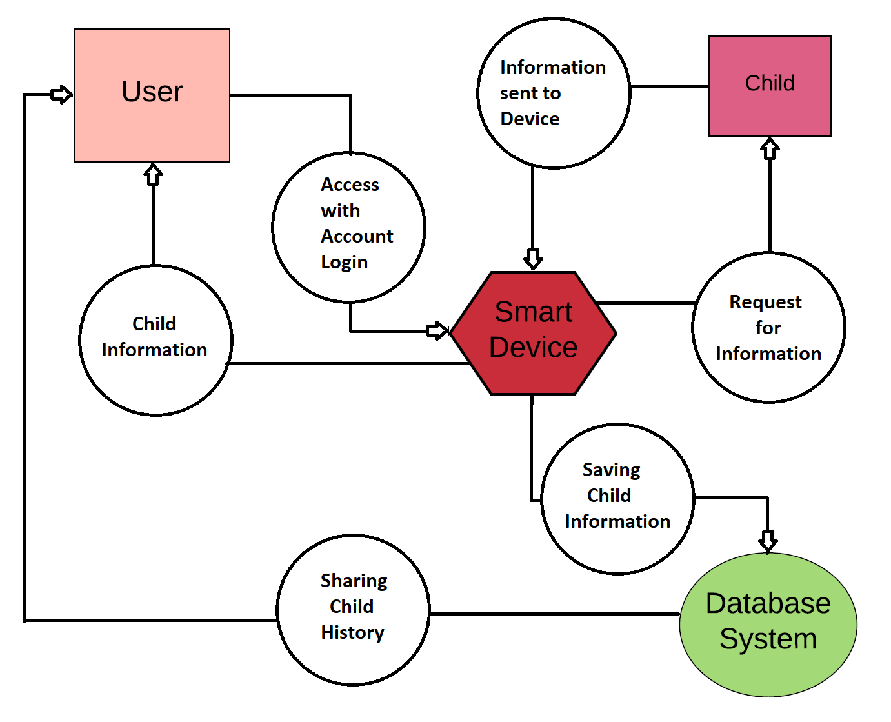
Data Flow Diagram

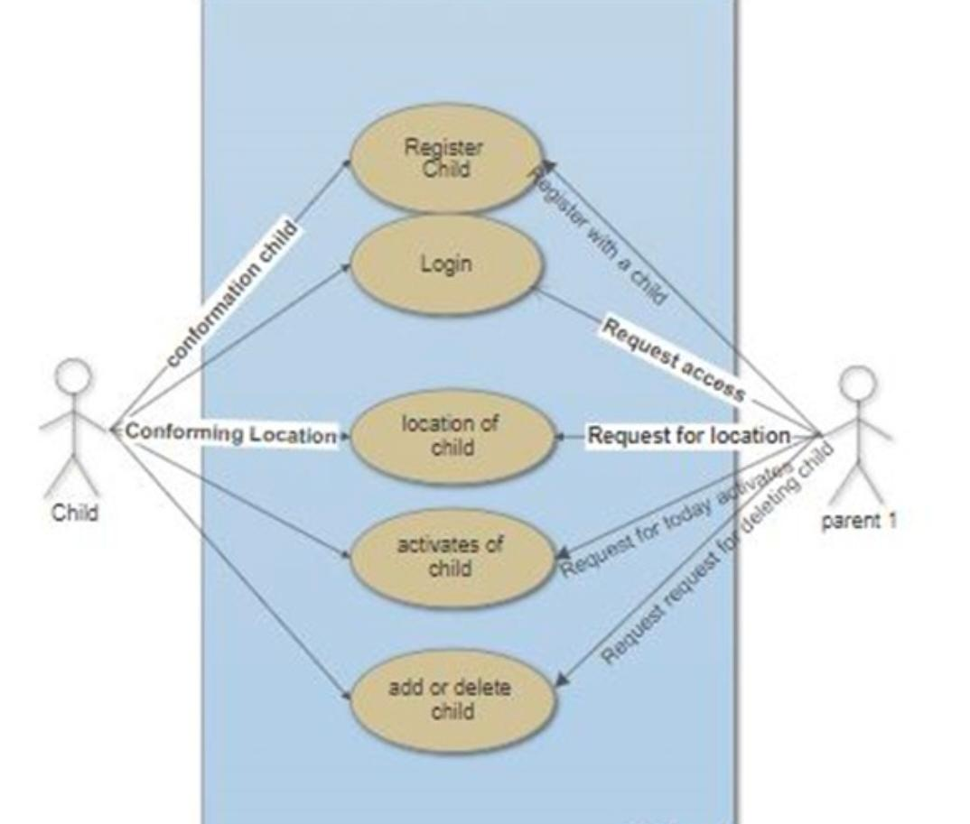

Use Case Diagram

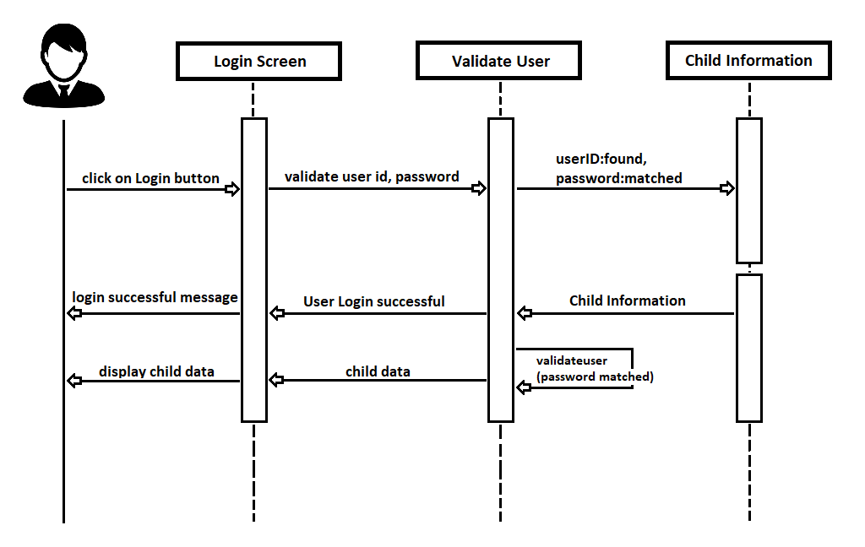

Sequence Diagram

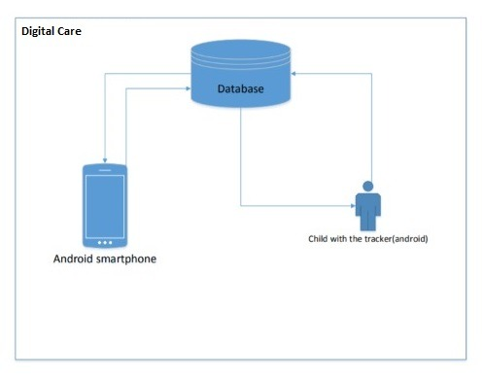
Architecture Diagraam

5.Implementation Code snippets of the functional requirements

Parent_live_location_OfChild.java
package com.example.digitalcare.ui.gallery;
import android.Manifest;
import android.app.AlertDialog;
import android.app.Dialog;
import android.content.Context;
import android.content.DialogInterface;
import android.content.Intent;
import android.content.pm.PackageManager;
import android.graphics.Bitmap;
import android.graphics.BitmapFactory;
import android.graphics.Color;
import android.location.LocationManager;
import android.os.Bundle;
import android.util.Log;
import android.view.LayoutInflater;
import android.view.View;
import android.view.ViewGroup;
import android.widget.TextView;
import android.widget.Toast;
import androidx.annotation.DrawableRes;
import androidx.annotation.Nullable;
import androidx.annotation.NonNull;
import androidx.core.app.ActivityCompat;
import androidx.core.content.ContextCompat;
import androidx.fragment.app.Fragment;
import androidx.lifecycle.Observer;
import androidx.lifecycle.ViewModelProviders;
import com.bumptech.glide.Glide;
import com.bumptech.glide.request.target.SimpleTarget;
import com.bumptech.glide.request.transition.Transition;
import com.example.digitalcare.ConstantsFile.Constants;
import com.example.digitalcare.Main2Activity;
import com.example.digitalcare.R;
import com.google.android.gms.common.ConnectionResult;
import com.google.android.gms.common.GoogleApiAvailability;
import com.google.android.gms.maps.CameraUpdateFactory;
import com.google.android.gms.maps.GoogleMap;
import com.google.android.gms.maps.OnMapReadyCallback;
import com.google.android.gms.maps.SupportMapFragment;
import com.google.android.gms.maps.model.BitmapDescriptorFactory;
import com.google.android.gms.maps.model.Circle;
import com.google.android.gms.maps.model.CircleOptions;
import com.google.android.gms.maps.model.LatLng;
import com.google.android.gms.maps.model.Marker;
import com.google.android.gms.maps.model.MarkerOptions;
import com.google.android.gms.tasks.OnCompleteListener;
import com.google.android.gms.tasks.OnFailureListener;
import com.google.android.gms.tasks.Task;
import com.google.firebase.auth.FirebaseAuth;
import com.google.firebase.firestore.DocumentSnapshot;
import com.google.firebase.firestore.FirebaseFirestore;
import com.google.firebase.firestore.GeoPoint;
import com.google.firebase.firestore.QueryDocumentSnapshot;
import com.google.firebase.firestore.QuerySnapshot;
import com.google.maps.android.clustering.ClusterManager;
import java.io.IOException;
import java.io.InputStream;
import java.net.URL;
import java.security.Permission;
import java.util.ArrayList;
import java.util.Map;
import javax.xml.validation.Validator;
public class GalleryFragment extends Fragment implements OnMapReadyCallback {
private GalleryViewModel galleryViewModel;
GoogleMap map123;
private Boolean locationPermissionGranted = false;
private FirebaseFirestore db;
private int i;
public View onCreateView(@NonNull LayoutInflater inflater,
ViewGroup container, Bundle savedInstanceState) {
galleryViewModel =
ViewModelProviders.of(this).get(GalleryViewModel.class);
View root = inflater.inflate(R.layout.fragment_gallery, container, false);
//final TextView textView = root.findViewById(R.id.text_gallery);
galleryViewModel.getText().observe(this, new Observer<String>() {
@Override
public void onChanged(@Nullable String s) {
//textView.setText(s);
}
});
SupportMapFragment mapFragment = (SupportMapFragment) getChildFragmentManager().findFragmentById(R.id.frg); //use SuppoprtMapFragment for using in fragment instead of activity MapFragment = activity SupportMapFragment = fragment
mapFragment.getMapAsync(new OnMapReadyCallback() {
@Override
public void onMapReady(final GoogleMap mMap) {
//Toast.makeText(getActivity(), "Ok", Toast.LENGTH_SHORT).show();
map123 = mMap;
if (checkMapServices()) {
getLocationPermission();
//locationPermissionGranted = true;
//
if (locationPermissionGranted) {
mMap.setMyLocationEnabled(true);
}
//Adding Markers
db = FirebaseFirestore.getInstance();
FirebaseAuth mAuth;
mAuth = FirebaseAuth.getInstance();
db.collection("child")
.whereEqualTo("p_id", mAuth.getUid())
.get()
.addOnCompleteListener(new OnCompleteListener<QuerySnapshot>() {
@Override
public void onComplete(@NonNull Task<QuerySnapshot> task) {
Bitmap bitmap1;
if (task.isSuccessful()) {
if (task.getResult().isEmpty()) {
//Toast.makeText(MainActivity.this, "Empty", Toast.LENGTH_SHORT).show();
Toast.makeText(getContext(), "No Markers Added for this user", Toast.LENGTH_SHORT).show();
} else {
for (QueryDocumentSnapshot document : task.getResult()) {
//Log.d("working", document.getId() + " => " + document.getData());
//Log.d("name", document.getString("name"));
//Toast.makeText(MainActivity.this, document.getId(), Toast.LENGTH_SHORT).show();
//Log.d("test", "onComplete: ");
try {
GeoPoint geoPoint = document.getGeoPoint("geoPoint");
final LatLng latLng = new LatLng(geoPoint.getLatitude(), geoPoint.getLongitude());
final QueryDocumentSnapshot document1 = document;
Glide.with(getContext())
.asBitmap()
.load(document1.getString("dpDownloadUrl"))
.fitCenter()
.into(new SimpleTarget<Bitmap>() {
int scaleSize =350;
public Bitmap resizeImageForImageView(Bitmap bitmap) {
Bitmap resizedBitmap = null;
int originalWidth = bitmap.getWidth();
int originalHeight = bitmap.getHeight();
int newWidth = -1;
int newHeight = -1;
float multFactor = -1.0F;
if(originalHeight > originalWidth) {
newHeight = scaleSize ;
multFactor = (float) originalWidth/(float) originalHeight;
newWidth = (int) (newHeight*multFactor);
} else if(originalWidth > originalHeight) {
newWidth = scaleSize ;
multFactor = (float) originalHeight/ (float)originalWidth;
newHeight = (int) (newWidth*multFactor);
} else if(originalHeight == originalWidth) {
newHeight = scaleSize ;
newWidth = scaleSize ;
}
resizedBitmap = Bitmap.createScaledBitmap(bitmap, newWidth, newHeight, false);
return resizedBitmap;
}
@Override
public void onResourceReady(@NonNull Bitmap resource, @Nullable Transition<? super Bitmap> transition) {
//bitmap1 = resource;
/*resource.setWidth(250);
resource.setHeight(250);*/
resource = resizeImageForImageView(resource);
mMap.addMarker(new MarkerOptions().position(latLng).title(document1.getString("name"))
.icon(BitmapDescriptorFactory.fromBitmap(resource))
);
}
});
//View mCustomMarkerView = ((LayoutInflater) getContext().getSystemService(Context.LAYOUT_INFLATER_SERVICE)).inflate(R.layout.view_custom_marker, null);
mMap.moveCamera(CameraUpdateFactory.newLatLngZoom(latLng, 15));
} catch (Exception e) {
Toast.makeText(getContext(), e.getMessage(), Toast.LENGTH_SHORT).show();
}
try {
db.collection("Allowed_Markers")
.document(document.getId())
.get()
.addOnCompleteListener(new OnCompleteListener<DocumentSnapshot>() {
@Override
public void onComplete(@NonNull Task<DocumentSnapshot> task) {
if (task.isSuccessful()){
DocumentSnapshot documentSnapshot = task.getResult();
Map<String,Object> map = documentSnapshot.getData();
for (Map.Entry<String, Object> entry : map.entrySet()) {
//mMap.addMarker(new MarkerOptions().position())
GeoPoint geoPoint = (GeoPoint) entry.getValue();
LatLng latLng = new LatLng(geoPoint.getLatitude(),geoPoint.getLongitude());
String name = entry.getKey();
mMap.addMarker(new MarkerOptions().position(latLng).title(name).draggable(false)
.icon(BitmapDescriptorFactory.defaultMarker(BitmapDescriptorFactory.HUE_AZURE))
);
Circle circle = mMap.addCircle(new CircleOptions()
.center(latLng)
.radius(10000)
.strokeColor(Color.RED)
.fillColor(0x220000FF)
.strokeWidth(5)
);
//Log.d("lllllllllllll", String.valueOf(geoPoint.getLatitude()));
}
}
}
});
}catch (Exception e){
Toast.makeText(getContext(), e.getMessage(), Toast.LENGTH_SHORT).show();
}
/*db.collection("Allowed_Markers")
.document(document.getId())
.get()
.addOnCompleteListener(new OnCompleteListener<DocumentSnapshot>() {
@Override
public void onComplete(@NonNull Task<DocumentSnapshot> task1) {
if (task1.getResult() == null) {
//Toast.makeText(MainActivity.this, "Empty", Toast.LENGTH_SHORT).show();
Toast.makeText(getContext(), "No Markers Added for this user", Toast.LENGTH_SHORT).show();
} else {
for (QueryDocumentSnapshot document : task1.getResult()) {
}
}
});*/
}
}
} else {
Log.w("error", "Error getting documents.", task.getException());
//Toast.makeText(MainActivity.this, "Error", Toast.LENGTH_SHORT).show();
}
}
})
.addOnFailureListener(new OnFailureListener() {
@Override
public void onFailure(@NonNull Exception e) {
//Toast.makeText(MainActivity.this, "failed", Toast.LENGTH_SHORT).show();
}
});
//Ending adding markers
}
}
});
return root;
}
@Override
public void onCreate(@Nullable Bundle savedInstanceState) {
super.onCreate(savedInstanceState);
setRetainInstance(true);
}
@Override
public void onMapReady(GoogleMap googleMap) {
//googleMap.setMyLocationEnabled(true);
}
private boolean checkMapServices() {
if (isServicesOK()) {
if (isMapsEnabled()) {
return true;
}
}
return false;
}
private void buildAlertMessageNoGps() {
final AlertDialog.Builder builder = new AlertDialog.Builder(getContext());
builder.setMessage("This application requires GPS to work properly, enable it!!")
.setCancelable(false)
.setPositiveButton("Yes", new DialogInterface.OnClickListener() {
public void onClick(@SuppressWarnings("unused") final DialogInterface dialog, @SuppressWarnings("unused") final int id) {
Intent enableGpsIntent = new Intent(android.provider.Settings.ACTION_LOCATION_SOURCE_SETTINGS);
startActivityForResult(enableGpsIntent, Constants.PERMISSIONS_REQUEST_ENABLE_GPS);
}
});
final AlertDialog alert = builder.create();
alert.show();
}
public boolean isMapsEnabled() {
final LocationManager manager = (LocationManager) getActivity().getSystemService(Context.LOCATION_SERVICE);
if (!manager.isProviderEnabled(LocationManager.GPS_PROVIDER)) {
buildAlertMessageNoGps();
return false;
}
return true;
}
private void getLocationPermission() {
Toast.makeText(getContext(), "Working", Toast.LENGTH_SHORT).show();
if (ContextCompat.checkSelfPermission(getContext(),
Manifest.permission.ACCESS_FINE_LOCATION)
== PackageManager.PERMISSION_GRANTED) {
locationPermissionGranted = true;
} else {
requestPermissions(
new String[]{android.Manifest.permission.ACCESS_FINE_LOCATION},
Constants.PERMISSIONS_REQUEST_ACCESS_FINE_LOCATION);
}
}
public boolean isServicesOK() {
int available = GoogleApiAvailability.getInstance().isGooglePlayServicesAvailable(getContext());
if (available == ConnectionResult.SUCCESS) {
return true;
} else if (GoogleApiAvailability.getInstance().isUserResolvableError(available)) {
//an error occured but we can resolve it
//Log.d(TAG, "isServicesOK: an error occured but we can fix it");
Dialog dialog = GoogleApiAvailability.getInstance().getErrorDialog(getActivity(), available, Constants.ERROR_DIALOG_REQUEST);
dialog.show();
} else {
Toast.makeText(getContext(), "You can't make map requests", Toast.LENGTH_SHORT).show();
}
return false;
}
@Override
public void onRequestPermissionsResult(int requestCode,
@NonNull String permissions[],
@NonNull int[] grantResults) {
//locationPermissionGranted = false;
switch (requestCode) {
case Constants.PERMISSIONS_REQUEST_ACCESS_FINE_LOCATION: {
// If request is cancelled, the result arrays are empty.
if (grantResults.length > 0
&& grantResults[0] == PackageManager.PERMISSION_GRANTED) {
locationPermissionGranted = true;
map123.setMyLocationEnabled(true);
}
}
}
}
@Override
public void onActivityResult(int requestCode, int resultCode, Intent data) {
super.onActivityResult(requestCode, resultCode, data);
switch (requestCode) {
case Constants.PERMISSIONS_REQUEST_ENABLE_GPS: {
map123.setMyLocationEnabled(true);
}
}
}
}

Add_Child_Device.java

package com.example.digitalcare;
import androidx.annotation.NonNull;
import androidx.annotation.Nullable;
import androidx.appcompat.app.AppCompatActivity;
import androidx.core.app.ActivityCompat;
import androidx.core.app.ComponentActivity;
import androidx.core.content.ContextCompat;
import android.Manifest;
import android.app.ProgressDialog;
import android.content.Context;
import android.content.Intent;
import android.content.SharedPreferences;
import android.content.pm.PackageManager;
import android.location.Location;
import android.location.LocationManager;
import android.net.Uri;
import android.os.Bundle;
import android.util.Log;
import android.view.View;
import android.view.WindowManager;
import android.widget.EditText;
import android.widget.TextView;
import android.widget.Toast;
import com.example.digitalcare.Bean.ChildDetails;
import com.example.digitalcare.ConstantsFile.Constants;
import com.google.android.gms.location.FusedLocationProviderClient;
import com.google.android.gms.location.LocationServices;
import com.google.android.gms.tasks.OnCompleteListener;
import com.google.android.gms.tasks.OnFailureListener;
import com.google.android.gms.tasks.OnSuccessListener;
import com.google.android.gms.tasks.Task;
import com.google.firebase.auth.FirebaseAuth;
import com.google.firebase.firestore.DocumentReference;
import com.google.firebase.firestore.FirebaseFirestore;
import com.google.firebase.firestore.GeoPoint;
import com.google.firebase.firestore.SetOptions;
import com.google.firebase.storage.FirebaseStorage;
import com.google.firebase.storage.StorageReference;
import com.google.firebase.storage.UploadTask;
import java.util.HashMap;
import java.util.Map;
public class AddChildDevice extends AppCompatActivity {
private Uri imageUri = null;
private FusedLocationProviderClient fusedLocationProviderClient;
private StorageReference mStorageRef;
private FirebaseFirestore db;
private GeoPoint geoPoint;
private ProgressDialog progressDialog;
private FirebaseAuth mAuth;
private boolean gpsEnabled = false;
@Override
protected void onCreate(Bundle savedInstanceState) {
super.onCreate(savedInstanceState);
setContentView(R.layout.activity_add_child_device);
fusedLocationProviderClient = LocationServices.getFusedLocationProviderClient(this);
mStorageRef = FirebaseStorage.getInstance().getReference();
mAuth = FirebaseAuth.getInstance();
db = FirebaseFirestore.getInstance();
}
public void chooseFile(View view) {
if (ContextCompat.checkSelfPermission(AddChildDevice.this, Manifest.permission.READ_EXTERNAL_STORAGE) == PackageManager.PERMISSION_GRANTED) {
selectImage();
} else {
ActivityCompat.requestPermissions(AddChildDevice.this, new String[]{Manifest.permission.READ_EXTERNAL_STORAGE}, Constants.PERMISSION_REQUESET_READ_EXTERNAL_STORAGE);
}
}
//File choosing
private void selectImage() {
Intent intent = new Intent();
intent.setType("image/*");
intent.setAction(Intent.ACTION_GET_CONTENT);
startActivityForResult(Intent.createChooser(intent, "Select Picture"), Constants.SELECT_FILE_CODE);
}
@Override
protected void onActivityResult(int requestCode, int resultCode, @Nullable Intent data) {
super.onActivityResult(requestCode, resultCode, data);
if (requestCode == Constants.SELECT_FILE_CODE && resultCode == RESULT_OK && data != null) {
imageUri = data.getData();
Toast.makeText(this, imageUri.toString(), Toast.LENGTH_SHORT).show();
} else if (requestCode == Constants.PERMISSIONS_REQUEST_ENABLE_GPS) {
LocationManager service = (LocationManager) getSystemService(LOCATION_SERVICE);
boolean enabled = service.isProviderEnabled(LocationManager.GPS_PROVIDER);
if (!enabled) {
Toast.makeText(this, "Please Enable GPS", Toast.LENGTH_SHORT).show();
Intent enableGpsIntent = new Intent(android.provider.Settings.ACTION_LOCATION_SOURCE_SETTINGS);
startActivityForResult(enableGpsIntent, Constants.PERMISSIONS_REQUEST_ENABLE_GPS);
} else {
gpsEnabled = true;
}
} else {
Toast.makeText(this, "NON of Permission", Toast.LENGTH_SHORT).show();
}
}
@Override
public void onRequestPermissionsResult(int requestCode, @NonNull String[] permissions, @NonNull int[] grantResults) {
//super.onRequestPermissionsResult(requestCode, permissions, grantResults);
if (requestCode == Constants.PERMISSION_REQUESET_READ_EXTERNAL_STORAGE && grantResults[0] == PackageManager.PERMISSION_GRANTED) {
selectImage();
} else if (requestCode == Constants.PERMISSIONS_REQUEST_ACCESS_FINE_LOCATION && grantResults[0] == PackageManager.PERMISSION_GRANTED) {
LocationManager service = (LocationManager) getSystemService(LOCATION_SERVICE);
boolean enabled = service.isProviderEnabled(LocationManager.GPS_PROVIDER);
// Check if enabled and if not send user to the GPS settings
if (!enabled) {
Intent enableGpsIntent = new Intent(android.provider.Settings.ACTION_LOCATION_SOURCE_SETTINGS);
startActivityForResult(enableGpsIntent, Constants.PERMISSIONS_REQUEST_ENABLE_GPS);
Toast.makeText(this, "Enable GPS inorder to use the app", Toast.LENGTH_SHORT).show();
} else {
gpsEnabled = true;
}
} else if (requestCode == Constants.PERMISSIONS_REQUEST_ENABLE_GPS && grantResults[0] == PackageManager.PERMISSION_GRANTED) {
Toast.makeText(this, "GPS enabled", Toast.LENGTH_SHORT).show();
} else {
Toast.makeText(this, "Read Permission should be granted inorder to upload File", Toast.LENGTH_SHORT).show();
}
}
//file choosing code ends here
//Granting permission
public void grantLocationGPSPermission(View view) {
if (ContextCompat.checkSelfPermission(this, Manifest.permission.ACCESS_FINE_LOCATION) == PackageManager.PERMISSION_GRANTED) {
LocationManager service = (LocationManager) getSystemService(LOCATION_SERVICE);
boolean enabled = service.isProviderEnabled(LocationManager.GPS_PROVIDER);
if (!enabled) {
Intent enableGpsIntent = new Intent(android.provider.Settings.ACTION_LOCATION_SOURCE_SETTINGS);
startActivityForResult(enableGpsIntent, Constants.PERMISSIONS_REQUEST_ENABLE_GPS);
} else {
gpsEnabled = true;
}
} else {
ActivityCompat.requestPermissions(this,
new String[]{android.Manifest.permission.ACCESS_FINE_LOCATION},
Constants.PERMISSIONS_REQUEST_ACCESS_FINE_LOCATION);
}
}
public void saveData(View view) {
try {
EditText ed5 = findViewById(R.id.editText5);
if (ed5.getText().toString() == null) {
Toast.makeText(this, "Please enter child's name", Toast.LENGTH_SHORT).show();
} else if (!gpsEnabled) {
Toast.makeText(this, "Please enable GPS", Toast.LENGTH_SHORT).show();
} else if (imageUri == null) {
Toast.makeText(this, "Please select profile image and enable ", Toast.LENGTH_SHORT).show();
} else {
try {
progressDialog = new ProgressDialog(this);
progressDialog.setProgressStyle(ProgressDialog.STYLE_HORIZONTAL);
progressDialog.setTitle("Updating Profile...Plz be patience");
progressDialog.setProgress(0);
progressDialog.show();
progressDialog.setCancelable(false);
fusedLocationProviderClient.getLastLocation().addOnCompleteListener(new OnCompleteListener<Location>() {
@Override
public void onComplete(@NonNull Task<Location> task) {
if (task.isSuccessful()) {
Location location = task.getResult();
Log.d("latt", String.valueOf(location.getLatitude()));
//Log.d("latt", String.valueOf(geoPoint.getLatitude()));
geoPoint = new GeoPoint(location.getLatitude(), location.getLongitude());
progressDialog.setProgress(10);
}
}
});
//firestore
ChildDetails childUserVar = new ChildDetails(ed5.getText().toString(), mAuth.getUid(), geoPoint);
db.collection("child")
.add(childUserVar)
.addOnSuccessListener(new OnSuccessListener<DocumentReference>() {
@Override
public void onSuccess(DocumentReference documentReference) {
//Log.d(TAG, "DocumentSnapshot added with ID: " + documentReference.getId());
//Toast.makeText(AddChildDevice.this, documentReference.getId(), Toast.LENGTH_SHORT).show();
progressDialog.setProgress(50);
final String documentID = documentReference.getId();
Uri file = imageUri;
String arg = "childDp/" + documentReference.getId() + ".jpg";
final StorageReference riversRef = mStorageRef.child(arg);
riversRef.putFile(file)
.addOnSuccessListener(new OnSuccessListener<UploadTask.TaskSnapshot>() {
@Override
public void onSuccess(UploadTask.TaskSnapshot taskSnapshot) {
// Get a URL to the uploaded content
// taskSnapshot.getMetadata().getReference().getDownloadUrl()
progressDialog.setProgress(70);
Task<Uri> downloadUrl1 = taskSnapshot.getMetadata().getReference().getDownloadUrl();
downloadUrl1.addOnSuccessListener(new OnSuccessListener<Uri>() {
@Override
public void onSuccess(Uri uri) {
progressDialog.setProgress(90);
Toast.makeText(AddChildDevice.this, uri.toString(), Toast.LENGTH_SHORT).show();
Map<String, Object> data = new HashMap<>();
data.put("dpDownloadUrl", uri.toString());
progressDialog.setProgress(95);
db.collection("child").document(documentID)
.set(data, SetOptions.merge())
.addOnSuccessListener(new OnSuccessListener<Void>() {
@Override
public void onSuccess(Void aVoid) {
//getWindow().clearFlags(WindowManager.LayoutParams.FLAG_NOT_TOUCHABLE);
progressDialog.hide();
Toast.makeText(AddChildDevice.this, "Success heeerrreeeeeeeeeee", Toast.LENGTH_SHORT).show();
SharedPreferences sharedPreferences = getSharedPreferences(Constants.SHARED_PREFERENCE, MODE_PRIVATE);
SharedPreferences.Editor editor = sharedPreferences.edit();
editor.putString(Constants.TYPE, "CHILD");
//editor.putString(Constants.ID,mAuth.getUid());
editor.putString(Constants.CHILD_ID, documentID);
editor.apply();
Intent i = new Intent(AddChildDevice.this, MapsActivity.class);
startActivity(i);
}
})
.addOnFailureListener(new OnFailureListener() {
@Override
public void onFailure(@NonNull Exception e) {
progressDialog.hide();
Toast.makeText(AddChildDevice.this, "An error occured check your internet connection", Toast.LENGTH_SHORT).show();
}
});
}
});
}
})
.addOnFailureListener(new OnFailureListener() {
@Override
public void onFailure(@NonNull Exception exception) {
progressDialog.hide();
Toast.makeText(AddChildDevice.this, "An error occured check your internet connection", Toast.LENGTH_SHORT).show();
}
});
}
})
.addOnFailureListener(new OnFailureListener() {
@Override
public void onFailure(@NonNull Exception e) {
progressDialog.hide();
Toast.makeText(AddChildDevice.this, "An error occured check your internet connection", Toast.LENGTH_SHORT).show();
}
});
} catch (Exception e) {
Log.d("errorrrrr", e.getMessage());
}
}
} catch (Exception e) {
Toast.makeText(this, e.getMessage(), Toast.LENGTH_SHORT).show();
}
}
public void resetDelete(View view) {
EditText ed5 = findViewById(R.id.editText5);
ed5.setText("");
imageUri = null;
Toast.makeText(this, "Image and name has been reset", Toast.LENGTH_SHORT).show();
}
}

6.User Interfaces/Screenshots with Descriptions

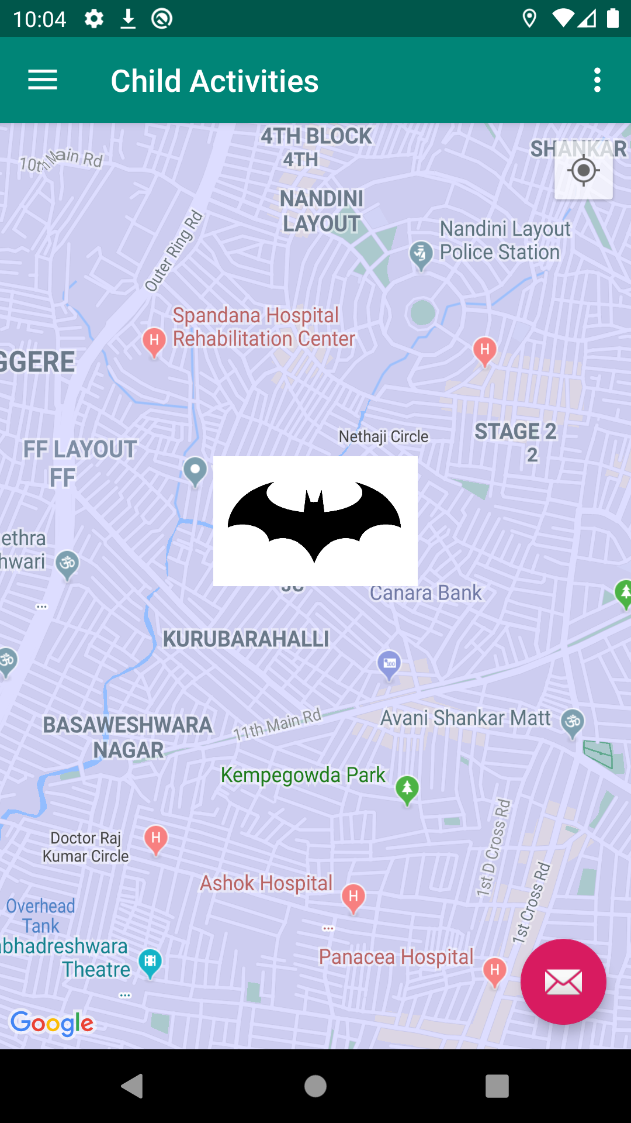

7. Conclusion and Scope for Further Enhancement

In conclusion, this system was developed to locate children for their parents and the GPS tracking technology is a practical option for monitoring and tracking a child’s position
Finally for this application has room for the enhancement. Emergency alerts such features can be added to enhance system. The proposed system will be improved in the later work.
Adv:
For this application automatic operation of location update without user interaction takes place. Because at that time child don’t haveknowledge to update hislocation at map. Another advantage is that application sends SMS when internet is not available. The system requires location and telephony services. Third advantage is it can be used at indoors where GPS satellites connectivity is not available. At that time it can uses network provides for location services.
Bibliography

- YouTube
- StackOverFlow
- GitHub
- Android developers

